Computer graphics is a discipline which takes a program and produces an image. Computer vision is a discipline which takes an image and extracts features to be used in a program. These two disciplines intersect on the topic differentiable rendering.

For my course project, I will be attempting to implement and modify projects from the Realistic Graphics Lab (RGL) at EPFL, Switzerland. Their team has developed Mitsuba, a “research-oriented rendering system for forward and inverse light transport simulation” and Dr. Jit, a “just-in-time compiler for ordinary and differentiable computation”. Using Mitsuba and Dr. Jit, RGL has, among other things, produced 3d models from images, made shadow art with projective sampling integrators, and generated objects which produce an image with caustics.

1. Shadow art with projective sampling integrators

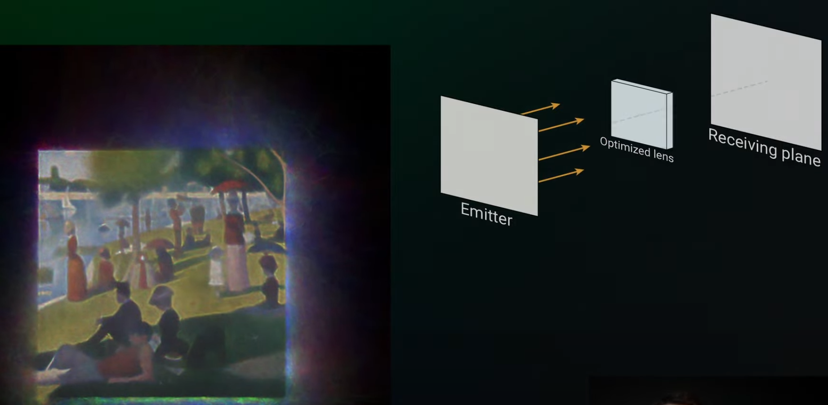

2. Producing images with caustics

RGL has published documentation, sample projects, and tutorials on how to use Mitsuba and Dr. Jit. I will begin by attempting to implement some of the tutorial projects from this playlist: <https://www.youtube.com/playlist?list=PLI9y-85z_Po6da-pyTNGTns2n4fhpbLe5>

As a stretch goal, I will attempt to implement more of their projects.

Mitsuba documentation: <https://mitsuba.readthedocs.io/en/latest/>

Dr. Jit documentation: <https://drjit.readthedocs.io/en/latest/>